

**Market Research**

**Project: DNSS**

**Prepared by: JTM ABDULLAH KHALID**

Phase 1: Research and Conceptualization - Conduct extensive market research to identify emerging trends and user needs. Define a set of artificial features, such as image recognition, augmented reality, and intelligent scene analysis, that align with consumer demands.

Phase 2: Design and Prototyping - Develop a detailed design incorporating the chosen artificial features. Create a functional prototype to test the integration of these features, ensuring seamless performance and user-friendly interfaces.

Phase 3: Testing and Optimization - Rigorous testing to evaluate the prototype's reliability, accuracy, and overall performance. Collect user feedback to identify areas for improvement, and optimize the camera's algorithms and software for enhanced functionality and responsiveness.

Phase 4: Manufacturing and Assembly - Scale up production based on successful prototype testing. Collaborate with manufacturing partners to ensure mass production meets quality standards while maintaining cost-effectiveness.

|  |  |
| --- | --- |
| **PHASE 1** | **A.I features on pc** |
| **PHASE 2** | **Camera + platform** |
| **PHASE 3** | **Gimbal addition** |
| **PHASE 4** | **Multicamera addition** |

**Presented to: Dr. Aamir Irshad**

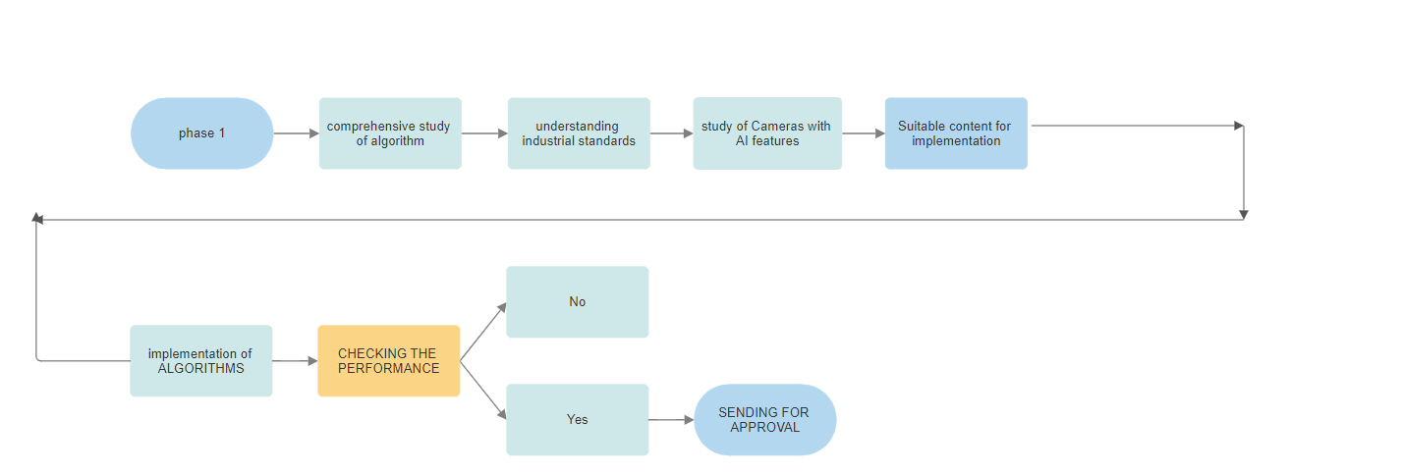

**Available resources.**

**Recommendations for new processors will be issued after comprehensive study.**

## Features

|  |  |  |  |  |  |  |  |
| --- | --- | --- | --- | --- | --- | --- | --- |
| **Model** | **ROCK (PI) 4A** | **ROCK (PI) 4B** | **ROCK (PI) 4C** | **ROCK (PI) 4A Plus** | **ROCK (PI) 4B Plus** | **ROCK 4 SE** | **ROCK (PI) 4C Plus** |
| **Processor** | 64bits hexa core processor Rockchip RK3399 Dual Cortex-72, frequency **1.8GHz** with qual Cortex-A53, frequency **1.4GHz** Mali T860MP4 gpu, support OpenGL ES 1.1/2.0/3.0/3.1/3.2, Vulkan 1.0, Open CL 1.1 1.2, DX11. | | | 64bits hexa core processor Rockchip OP1 Dual Cortex-72, frequency **2.0GHz** with qual Cortex-A53, frequency **1.5GHz** Mali T860MP4 gpu, support OpenGL ES 1.1/2.0/3.0/3.1/3.2, Vulkan 1.0, Open CL 1.1 1.2, DX11. | | 64bits hexa core processor Rockchip RK3399-T Dual Cortex-72, frequency **1.5GHz** with qual Cortex-A53, frequency **1.0GHz** Mali T860MP4 gpu, support OpenGL ES 1.1/2.0/3.0/3.1/3.2, Vulkan 1.0, Open CL 1.1 1.2, DX11. | |
| **Memory** | LPDDR4 64bit dual channel LPDDR4@3200Mb/s, 1GB/2GB/4GB optioal | | | | | | |
| **Storage** | eMMC connector μSD card (μSD slot supports up to 256 GB μSD card) M.2 SSD (M.2 connector supports up to 2T M2 NVME SSD) | | | on board eMMC with up to 128GB variant available μSD card (μSD slot supports up to 256 GB μSD card) M.2 SSD (M.2 connector supports up to 2T M2 NVME SSD) | | eMMC connector μSD card (μSD slot supports up to 256 GB μSD card) M.2 SSD (M.2 connector supports up to 2T M2 NVME SSD) | eMMC connector μSD card (μSD slot supports up to 256 GB μSD card) |
| **Display** | Standard HDMI 2.0 up to 4k@60 MIPI DSI 2 lanes via FPC connector HDMI and MIPI DSI can work at the same time, support mirror mode or extend mode. | | Mini DP up to 1440P@60 Micro HDMI 2.0 up to 4k@60 MIPI DSI 2 lanes via FPC connector HDMI and DP can work at the same time. | Standard HDMI 2.0 up to 4k@60 MIPI DSI 2 lanes via FPC connector HDMI and MIPI DSI can work at the same time, support mirror mode or extend mode. | | | One Micro HDMI 2K up to 1440P@60 One Micro HDMI 4K 2.0 up to 4k@60 MIPI DSI 4 lanes via FPC connector Only two of HDMI 2k, HDMI 4K and MIPI DSI can work at the same time. |
| **Audio** | 3.5mm jack with mic HD codec that supports up to 24-bit/96KHz audio. | | | | | | 3.5mm jack HD codec that supports up to 24-bit/96KHz audio. |
| **Camera** | MIPI CSI 2 lanes via FPC connector, support up to 800 MP camera(1mm pitch connector). | | | | | | MIPI CSI 2 lanes via FPC connector, support up to 800 MP camera(0.3mm pitch connector). |
| **Wireless** | None | 802.11 ac wifi BT 5.0 with on board antenna | | None | 802.11 ac wifi BT 5.0 with on board antenna | | 802.11 ac wifi BT 5.0 with external antenna |
| **USB** | USB 3.0 OTG X1, hardware switch for host/device switch, upper one USB 3.0 HOST X1, dedicated USB 3.0 channel, lower one USB 2.0 HOST X2 | | | | | | |
| **Ethernet** | GbE LAN | GbE LAN with Power over Ethernet (PoE) support additional HAT is required for powering from PoE | | GbE LAN | GbE LAN with Power over Ethernet (PoE) support additional HAT is required for powering from PoE | | |
| **IO** | 40-pin expansion header 2 x UART 2 x SPI bus 3 x I2C bus 1 x PCM/I2S 1 x SPDIF 2 x PWM 1 x ADC 6 x GPIO 2 x 5V DC power in 2 x 3.3V DC power in | | | | | | |
| **Others** | RTC RTC battery connector for time backup(optional) | | | | | | RTC None |
| **Power** | USB PD, support USB Type C PD 2.0, 9V/2A, 12V/2A. Qualcomm® Quick ChargeTM: Supports QC 3.0/2.0 adapter, 9V/2A, 12V/1.5A | | | | | | USB C 5V/3A |
| **Size** | 85mm x 54mm | | | | | | |